UAT Plan

for

GateWay

Index

1. Scope 3

1.1. Objectives and business requirements 3

1.2. Scope 3

2. Testing team 4

3. Environmental requirements 5

3.1. Hardware requirements 5

3.2. Software requirements 5

4. Test Scripts 1

# Scope

## Objectives and business requirements

The goal of this user acceptance test is to ensure that every part of a game controller designed for someone with muscular dystrophy to play Super Mario Bros. is designed correctly and efficiently.

## Scope

We are making a controller for Anna, a student with muscular dystrophy.

We are testing:

* Does the button work
* Does the joystick work
* Does the controller turn off
* Does the controller work with the game (Super Mario Bros.)

We are not testing:

* Damage resistance
* Does the controller work on other games

## System Diagrams

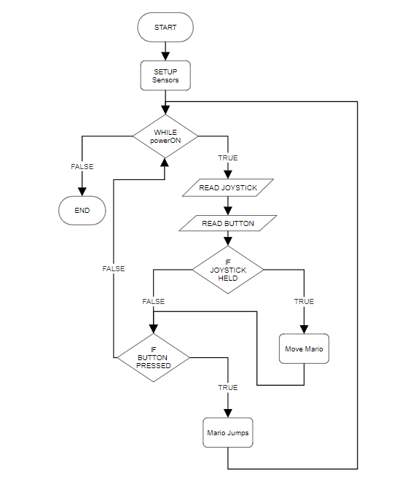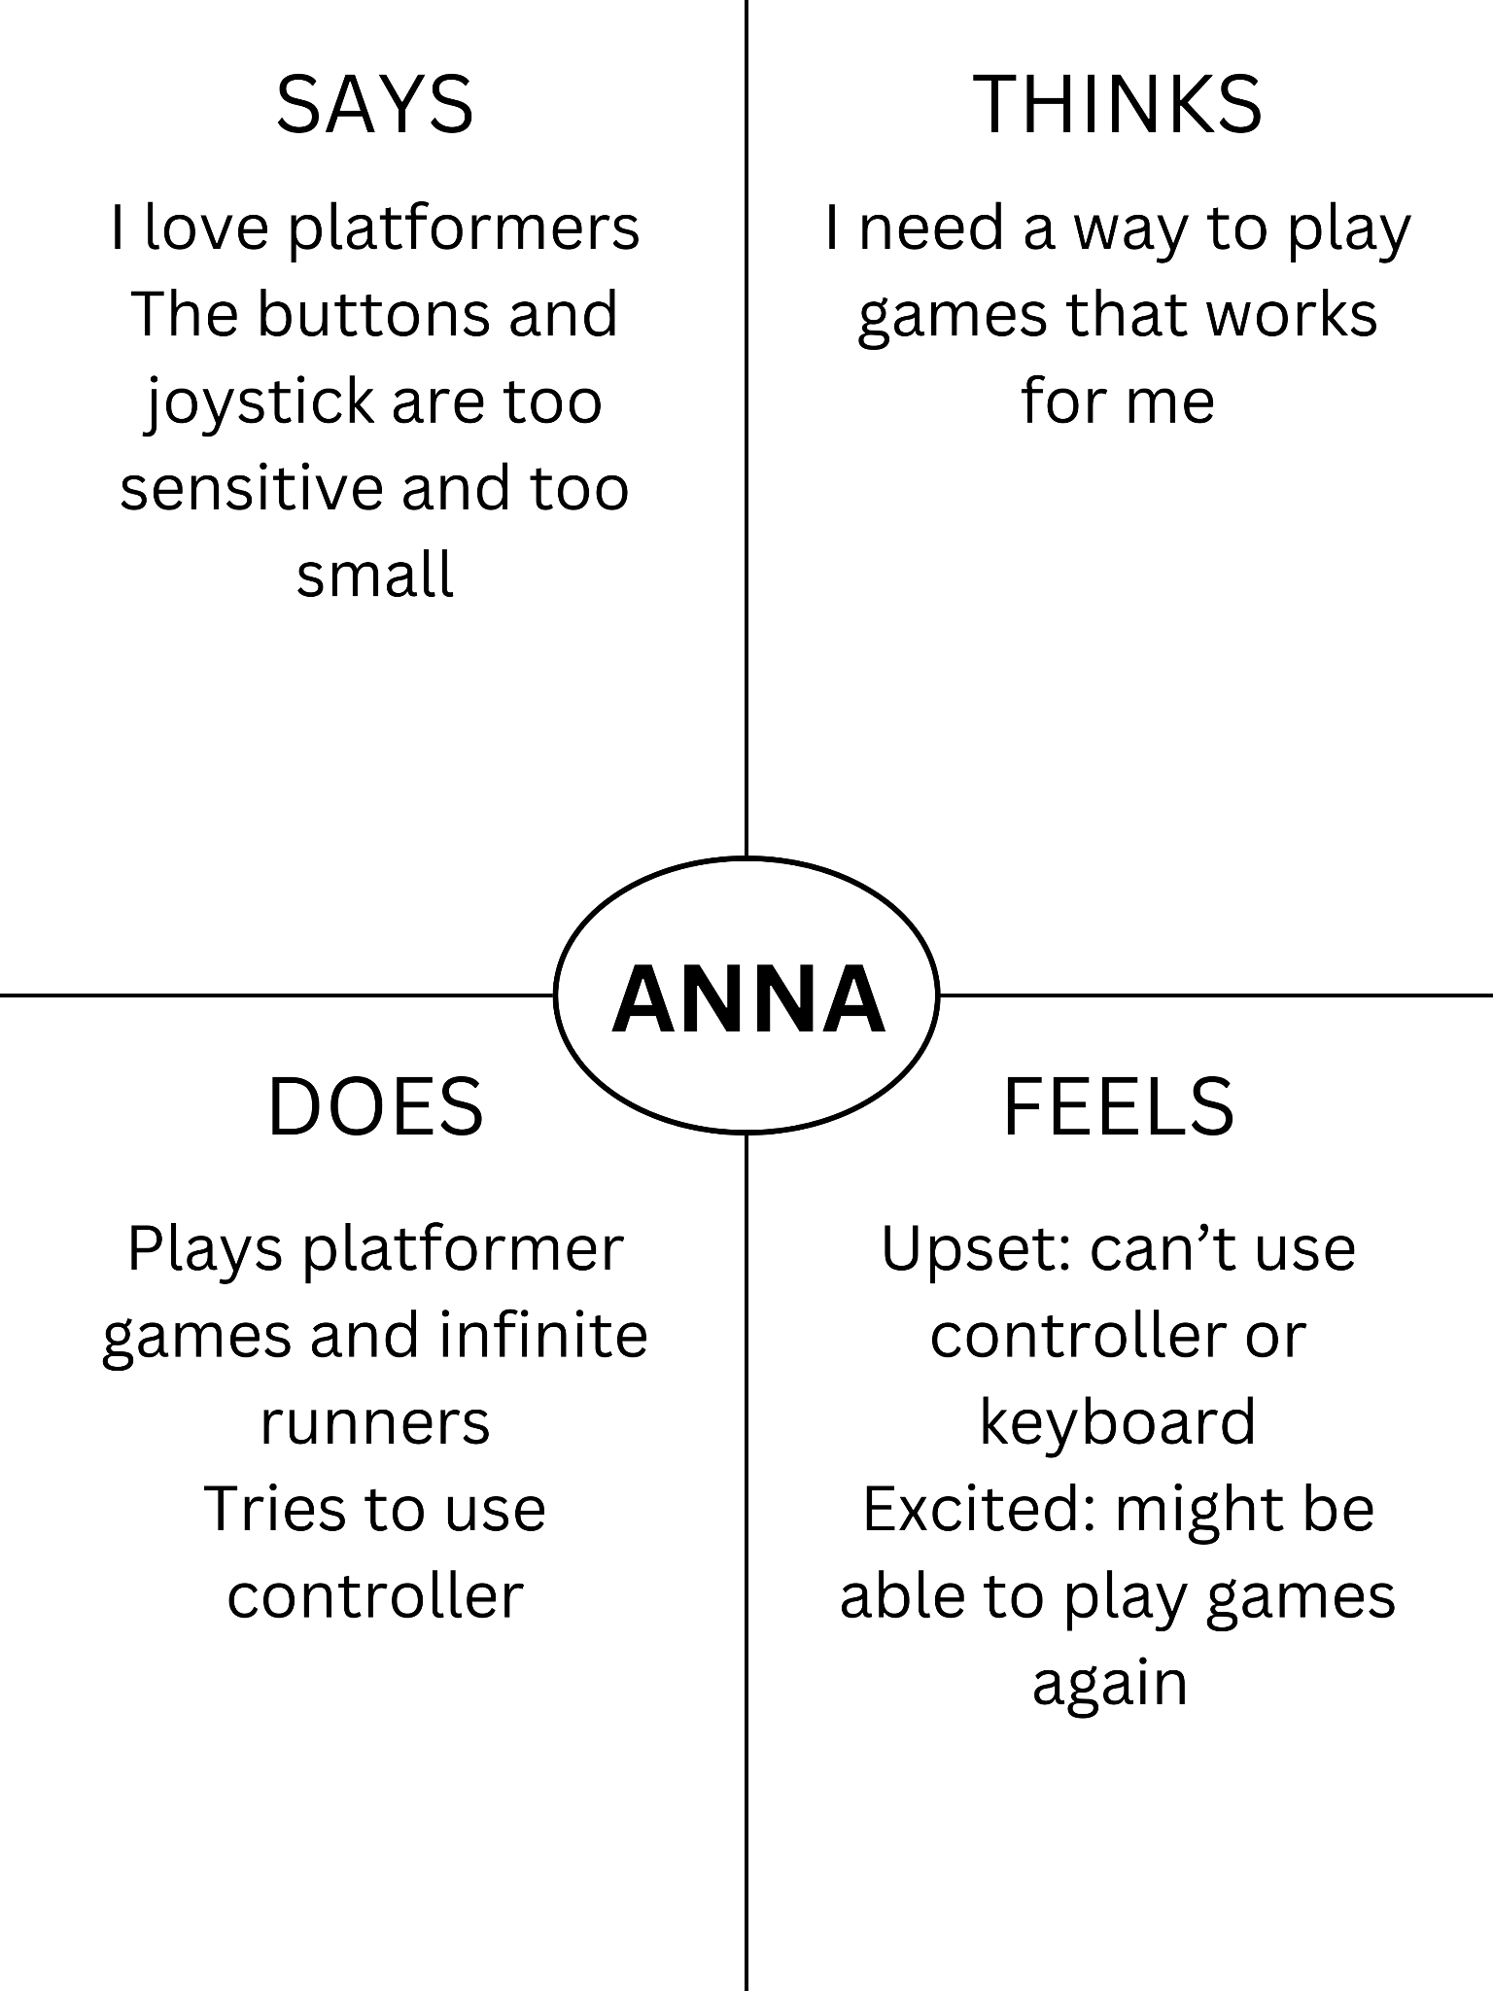

The flowchart represents the actions the user and program makes.

The empathy map shows that the designer has thought about what the user’s wants and needs are.

# Testing team

| **Name** | **Responsibilities** |
| --- | --- |
| Xavier Pritchett | Write UAT testing plan, designer, planner |
| Anna (User) | Test product, user |

# Environmental requirements

## Hardware requirements

Lenovo Laptop PC

* 32 or 64 bit Windows version
* Minimum 1200 MHz CPU
* At least 5 Mb free drive space
* 256 Mb RAM minimum.
* GPU with at least 64 Mb memory.

## Software requirements

Lenovo Laptop PC

* FCEUX emulator
* A copy of Super Mario Bros.

# Test Scripts

| **Test** | **Describe the feature being tested** | **Describe the user input or test data** | **Describe the pass criteria** |  |
| --- | --- | --- | --- | --- |
| 1.1 | The controller works with FCEUX | 1. User plugs in controller 2. User opens FCEUX 3. User opens controller config menu 4. User inputs the correct inputs to setup controller | 1. User sees windows controller connected notification 2. User sees FCEUX window 3. User sees config window 4. User’s inputs show on config menu | Tester name:   | X | PASS | | --- | --- | |  | FAIL |   Observations: |
| 1.2 | The controller makes mario move | 1. User opens game 2. User waits for cutscene 3. User moves the joystick in each direction starting from right going clockwise | Mario moves right, ducks then moves left. | Tester name:   | X | PASS | | --- | --- | |  | FAIL |   Observations: |
| 1.3 | The controller makes mario jump | 1. User opens game 2. User waits for cutscene 3. User presses the button | Mario jumps when the button is pressed. | Tester name:   | X | PASS | | --- | --- | |  | FAIL |   Observations: |